20MCA136 – NETWORKING & SYSTEM ADMINISTRATION LAB Dept. of Computer Applications

|  |
| --- |
| **Name: Kevin Chacko Abraham**  **Roll No: 13**  **Batch: RMCA(B)**  **Date:26/03/2021** |

**NETWORKING & SYSTEM ADMINISTRATION LAB**

**Experiment No: 6**

**Aim**

Familiarization of basic linux commands

**Procedure:**

1.$**cp filename1.txt filename2.txt–** cp command used to copy  **output:**

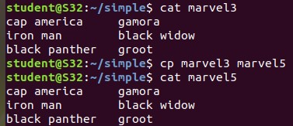

1. $**cp -r directory1 directory2**  - cp -r command is used to copy entire directory.**output:**

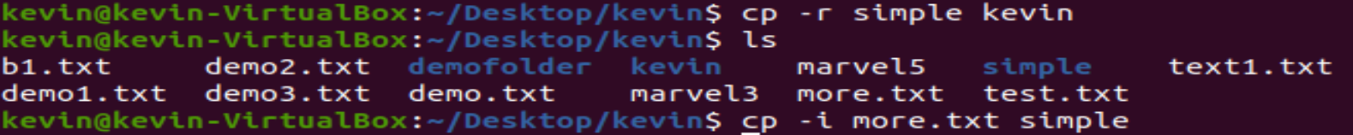

1. **$cp -i filename.txt directory**– this command is used to ask permission to overwrite  **output :**

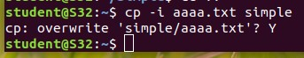

Amal Jyothi College Of Engineering , Kanjirappally 1 20MCA136 – NETWORKING & SYSTEM ADMINISTRATION LAB Dept. of Computer Applications

4.**$mv filename.txt directory** – mv command is used to move a file to another directory **output:**

**5.$mv -i filename.txt directory -** this command is used to ask permission to move one directory to anotherdirectory . **output:**

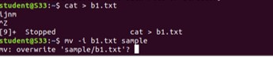

Amal Jyothi College Of Engineering , Kanjirappally 2